Coding is Fun
A Computing Competition
- 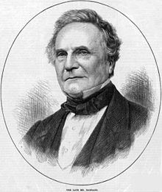Born in 1791, this Englishman was a computer pioneer
Who was he?

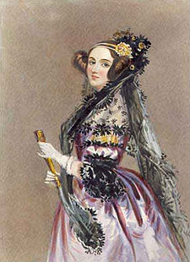This lady, born in 1815, worked with him
She probably wrote the first ever computer program
And has a computing language named after her
Who was she?

- 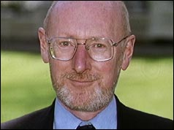This man designed this computer,
The first computer sold for under £100
It had 1k of RAM
Who is he?

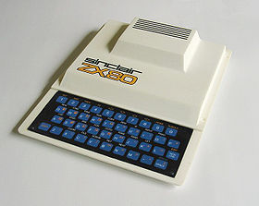Which city did he work in?

- You may have seen this man on television
Who is he?

What was his computer company called?

- 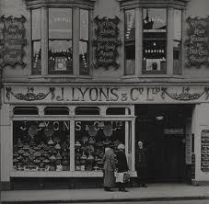Why was this chain of tea shops so important in the
history of computing?

And who or what was Leo?

- What do the following letters stand for?
CPU
GPU
RAM
ROM
USB
VGA
GPIO
PCI
DIMM
ZIF
SATA
HDD
ADSL
LAN
HTML
IDE (2 meanings)

CSS
ASCII
HDMI
- 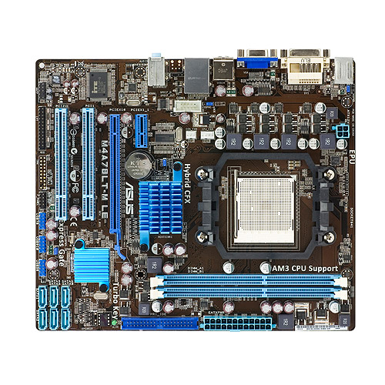How many parts of this motherboard can you name?
Draw arrows to show which bit is which

