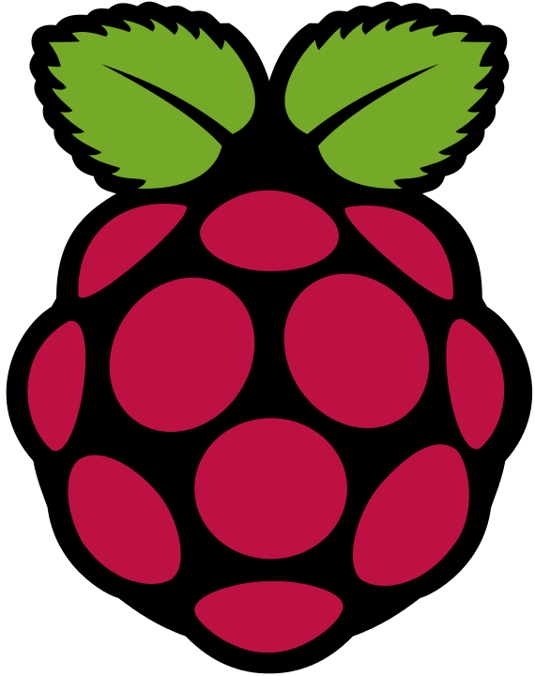I am a
Raspberry Pi
PLEASE
DO NOT TOUCH
ME
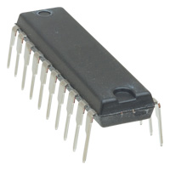I am a
PIC
PLEASE
DO NOT TOUCH
ME
Code Academy
Learning JavaScript
Scratch
Yes, this IS Coding!
‘C’ and OpenGL
On a Raspberry Pi
Just like your . . .
. . . PS3, Xbox, PC, Mac
Android Phone, iPhone
DIY Hardware
On a PIC
Play – Rock, Scissors, Paper

CODING
IS
FUN

